## UML Diagrams

### **UML Use Case Diagram**

### 

**UML Activity Diagrams**

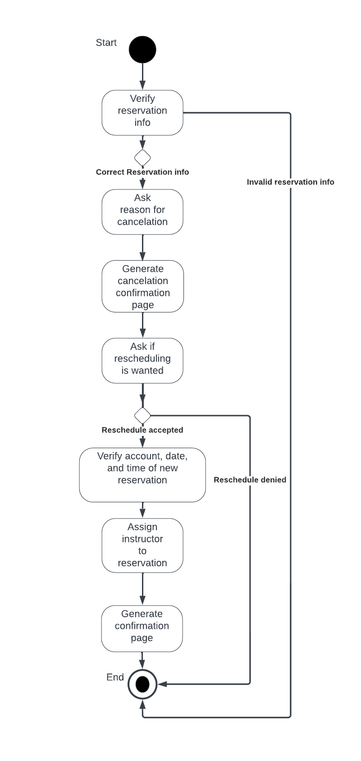

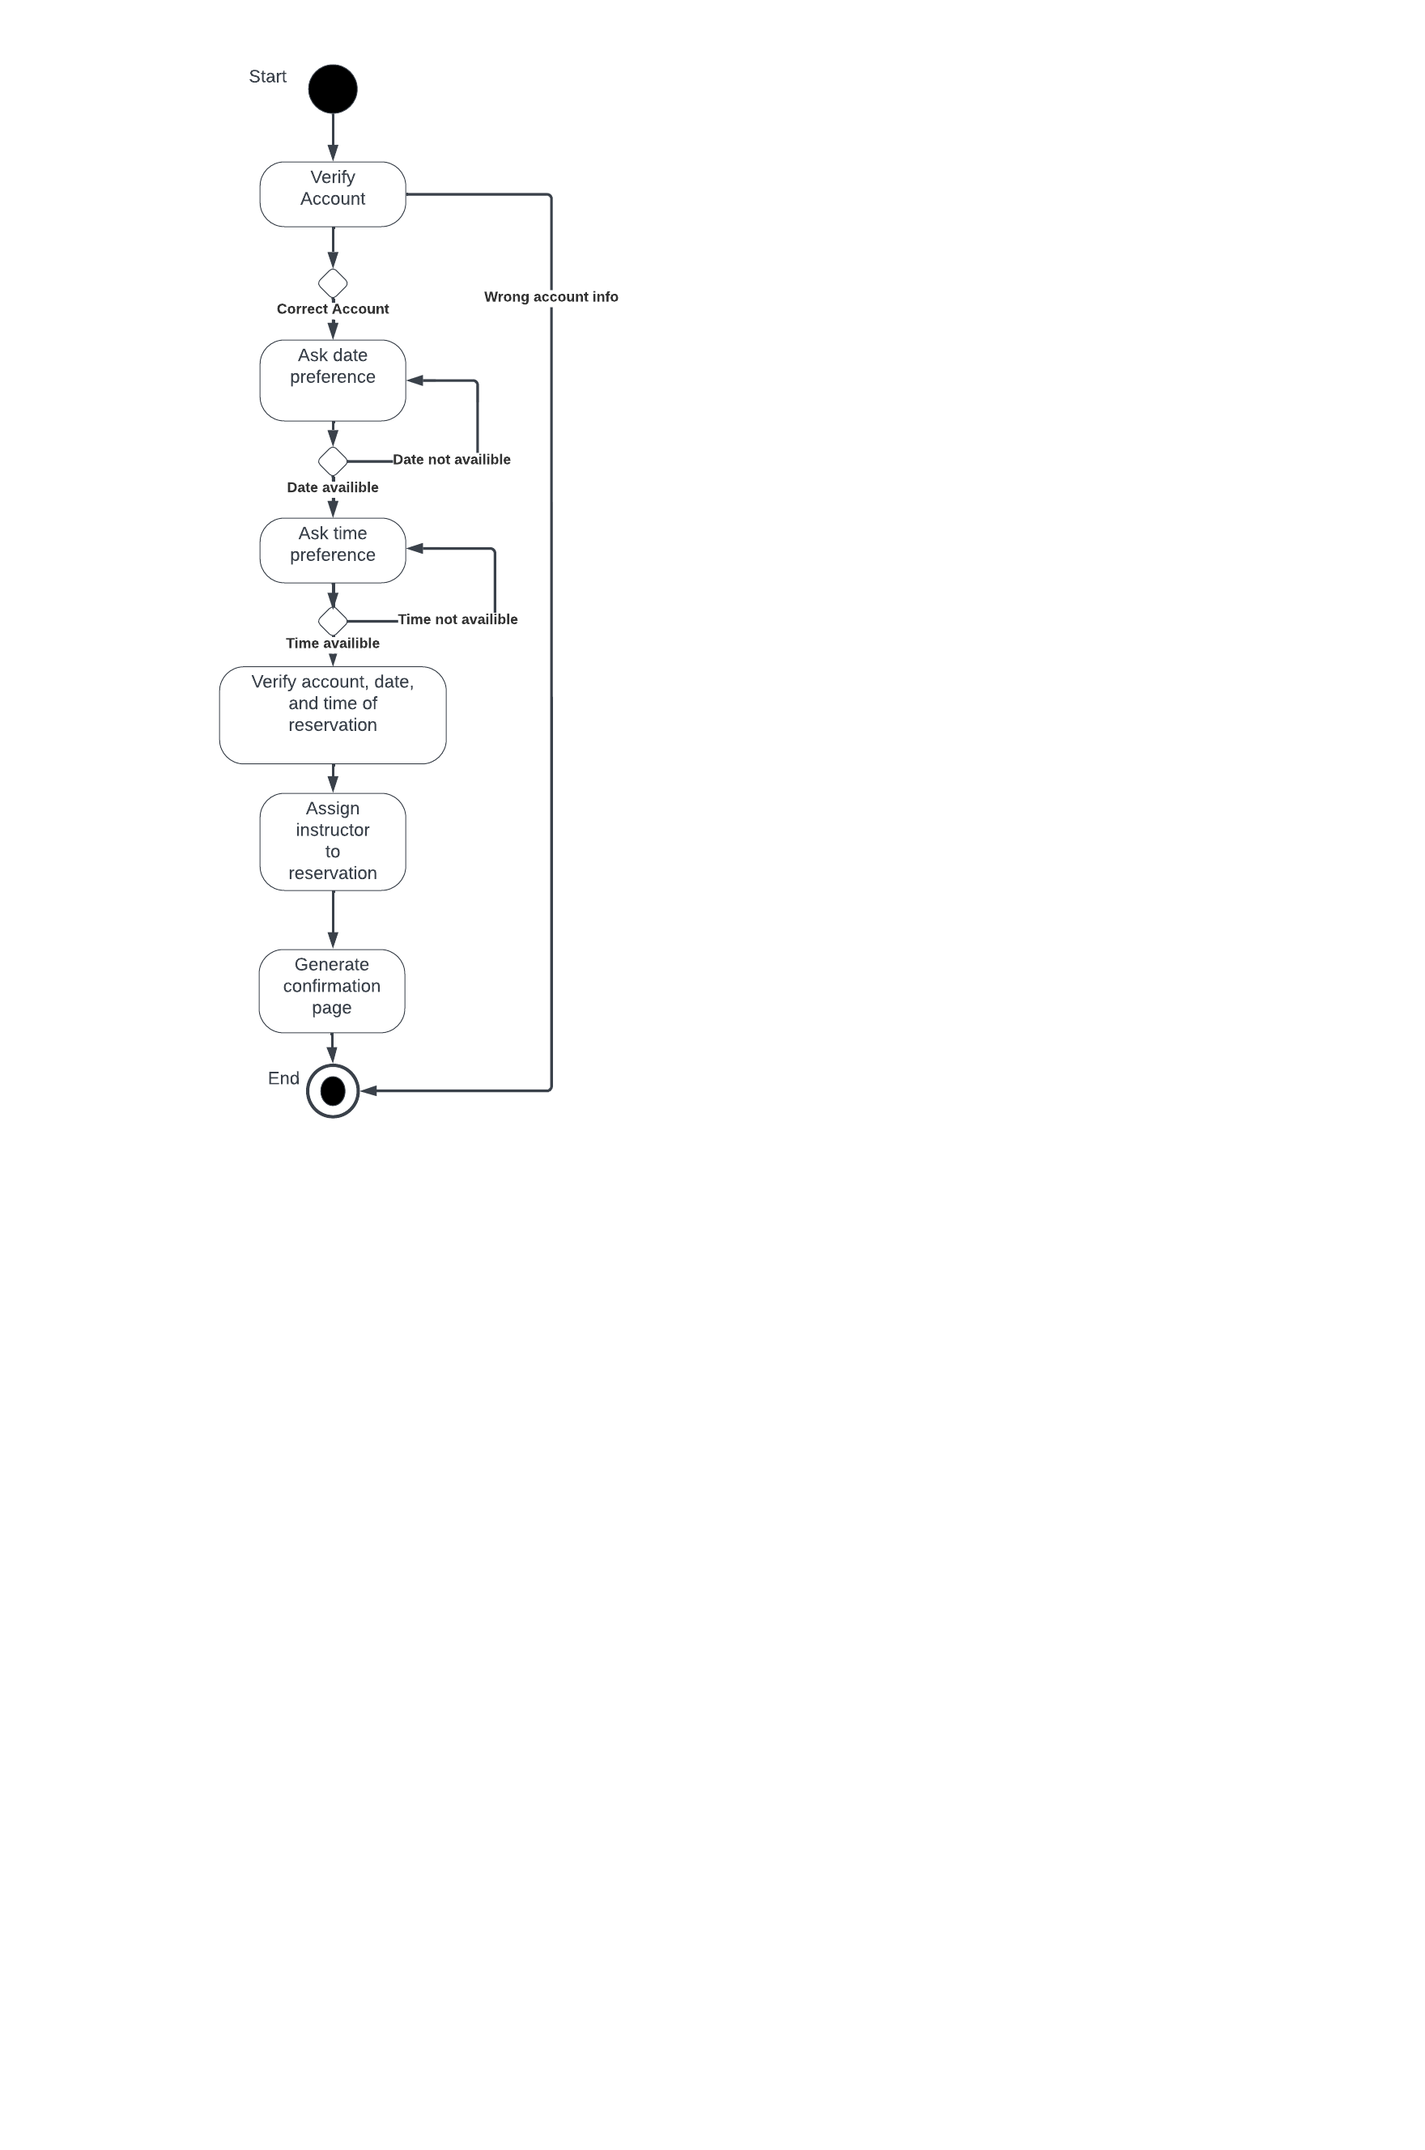

**UML Sequence Diagram**

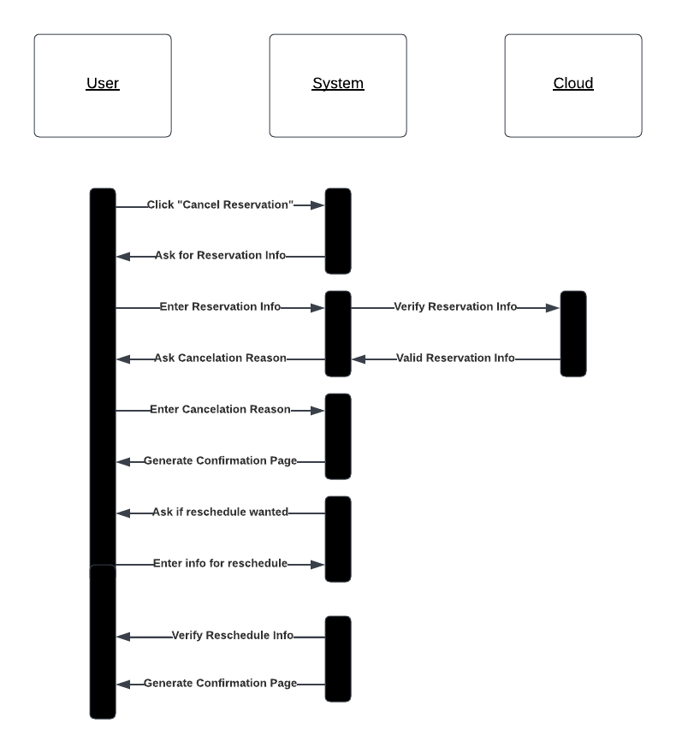

### UML Class Diagram

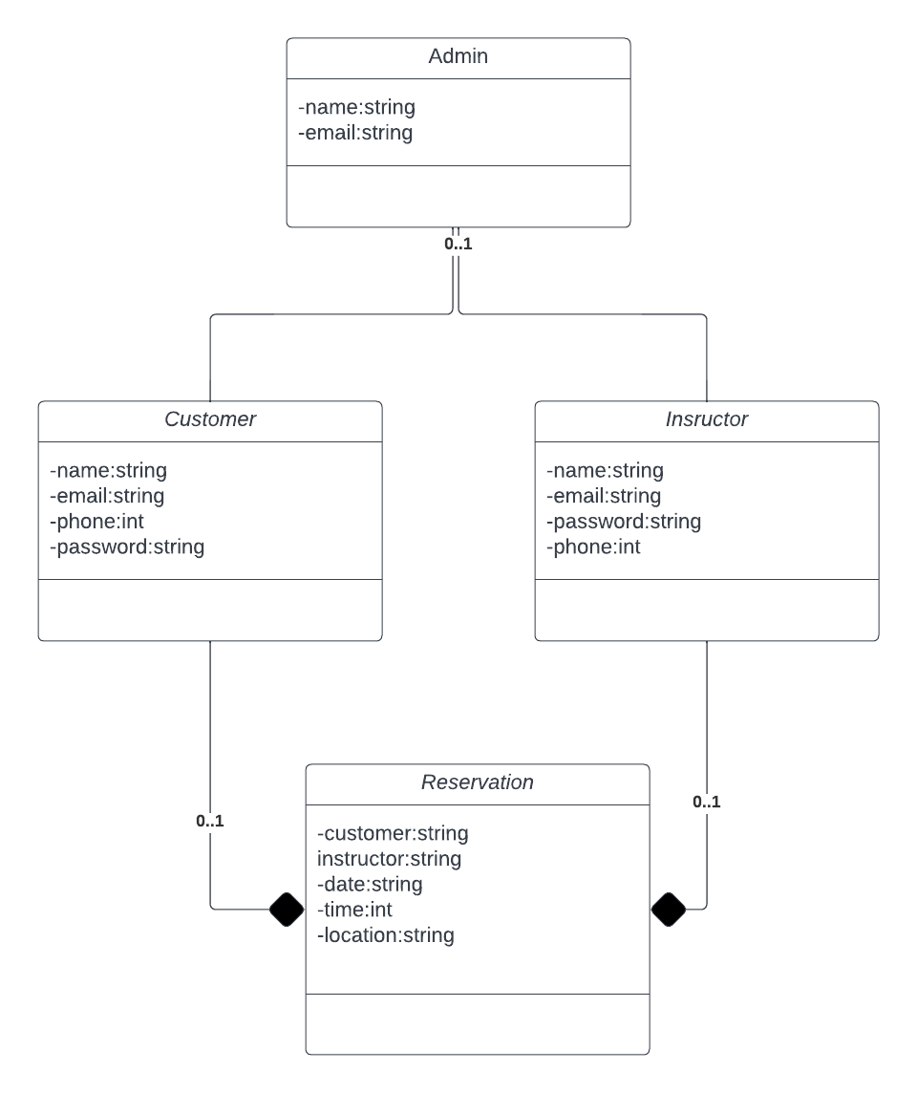

## Technical Requirements

*With this system design and from what the client mentioned, we would make this a cloud-based system not a web-based system. The required hardware should be fairly open to many different devices, things like phones, laptops, desktops, and more. I do believe the system should have its own server for memory management and allow for cloud-based storage for this system. This means a dedicated server room for would work great to keep things running smoothly if not then paying for servers from a dedicated company can work as well. Software and tools to check for code errors could also be very useful in fixing bugs timely but since this is not required.*